

Fabrication notes
LMM10-2602

January 8th, 2026

1. PCB construction

- Number of layers: 10
- Surface finish: Immersion gold.
- PCB Material requirement:
  - RoHS compliant
  - REACH compliant
- Dielectric material: must comply with IPC-4101E standard.
- Solder Mask: on both sides of the board, color green.
- All vias are tended on both sides unless the soldermask is opened in gerber.
- Layer stack shall comply with the IPC-6012F standard.
- Layout clearance shall comply with the IPC-2221C standard.

2. Gerber description and stackup

The layer structure is defined below:

- Layer Top → *.cmp
- Layer 2 → *.l2
- Layer 3 → *.l3
- Layer 4 → *.l4
- Layer 5 → *.l5
- Layer 6 → *.l6
- Layer 7 → *.l7
- Layer 8 → *.l8
- Layer 9 → *.l9
- Bottom → *.sol
- Solder Mask top → *.stc
- Solder Mask bottom → *.sts
- Dimension → *.dim
- Paste top → *.tcr
- Paste bottom → *.bcr
- Silkscreen top → *.tsilk
- Silkscreen bottom → *.bsilk
- Drills → *.drd
- Drills info → *.dri

The PCB stackup is described in the next image:
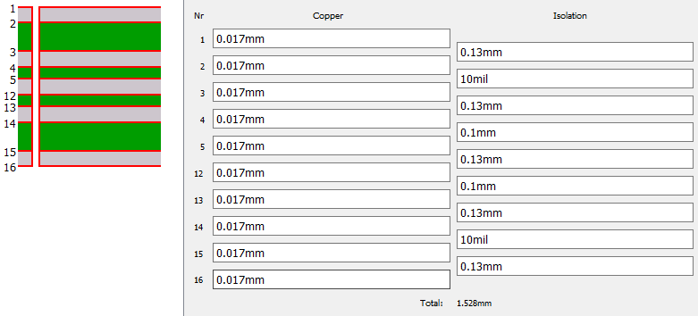
Note: final outer layers thickness of 48 μm aprox.

3. Drills

Number of drills: 1626
Drills used:
Code | Size | Used
T1 | 0.0079inch | 1606
T2 | 0.0291inch | 8
T3 | 0.0394inch | 5
T4 | 0.0453inch | 1
T5 | 0.0650inch | 1
T6 | 0.1457inch | 2
T7 | 0.1732inch | 3

4. Panel

A 10 mm wide frame shall be left around the panel to facilitate subsequent assembly of the components.
The joint between the frame and the panel must be milled.
On each side of the frame, two fiducials (2mm diameter circular copper mark with 3mm diameter Soldermask) will be drawn, both at the top and at the bottom at 5 mm from the edge and 15 mm from each corner.
The amount of PCBs in the panel shall be determined by the PCB manufacturer.
The panel shall be designed in a way to avoid bending during component assembly.
Small drills shall be foreseen in the joining between panel and frame to facilitate separation between them and avoid delamination during the process.

5. Silkscreen
The PCB shall have silkscreen in the bottom layer.
The gerber data for silkscreen is the *.bsilk.
Do not include manufacturing logos in the PCB.
The silkscreen color shall be white.
PCB manufacturers shall add a traceability number in the products. It shall be placed in the bottom layer.

6. Additional notes
The PCB manufacturing shall comply with the IPC-1602A standard to ensure a correct handling, protection and storage.

